Asymmetric DCC correlation: EURUSD and AUDUSD
Method 10 / GARCH(1,1) + Cappiello-Engle-Sheppard ADCC / Alpari D1 full available history

Study setup
Logical pair: EURUSD , AUDUSD
Broker symbols: EURUSD_i , AUDUSD_i
Snapshot: 2026-11-03_majors_alpari_D1
Timeframe: D1
Matched return window: 1999-01-05 to 2026-11-02 (UTC bar dates)
Matched return count n: 7201
Dropped unfinished last bar dated 2026-11-03 UTC after a tick-volume check against the prior complete day.
EURUSD GARCH(1,1): mu=0.000010, omega=0.001154, alpha=0.036727, beta=0.959984
AUDUSD GARCH(1,1): mu=0.000032, omega=0.005435, alpha=0.052433, beta=0.936914
ADCC: a=0.031206, b=0.960498, g=0.000000, a+b+g/2=0.991704
Nested DCC (g=0): a=0.031206, b=0.960498
Negative shock: n = min(z, 0) in broker quote direction (not inverted)
Burn-in ignored in path summaries and chart: first 60 updates
Complete matched rows (Excel): EURUSD-AUDUSD_ADCC_D1.xlsx
Complete matched rows (HTML table): EURUSD-AUDUSD_ADCC_D1_data.html

Method carried forward
Asymmetric DCC extends Engle DCC with an extra term on joint negative standardised shocks. Each matched daily log return of close, ln(close_t / close_t-1), is first filtered by a constant-mean GARCH(1,1). Then z = residual / sigma and n = min(z, 0). The Cappiello-Engle-Sheppard recursion uses A = (1-a-b) Q_bar - g N_bar with N_bar = mean(n n'). Quotes are not inverted, so a negative shock is a negative log return in the broker quote. Nested symmetric DCC (g = 0) is fit on the same z path for comparison. Constraints: a,b,g >= 0 and a + b + g/2 < 1. Path summaries ignore the first 60 updates. The headline is latest ADCC rho. Pearson r is a side check only. This is not a cause, lead, or trading signal.

Results
Latest ADCC rho: 0.392502
Latest nested DCC rho: 0.392502
Post-burn-in ADCC path (n=7141): mean=0.543084, median=0.584729, min=-0.165636, max=0.825794, std=0.157193
Share of post-burn-in days with |rho| >= 0.4: 81.88%; |rho| >= 0.7: 11.96%
Same-sample Pearson r: 0.556324
ADCC minus r: -0.163822
ADCC minus nested DCC: -0.000000

Conclusion
Over 7201 matched daily log-return rows for EURUSD and AUDUSD (broker quote directions unchanged), latest ADCC rho is 0.3925 (positive, weak conditional linear link in this sample) with fitted a=0.0312, b=0.9605, g=0.0000. Nested symmetric DCC latest rho is 0.3925 (ADCC minus DCC = -0.0000). After a 60-day burn-in, path mean is 0.5431 and std is 0.1572. Same-sample Pearson r is 0.5563 (ADCC minus r = -0.1638). This does not establish cause, lead-lag, or a lasting trading rule.

Charts
Daily closes

Daily log returns
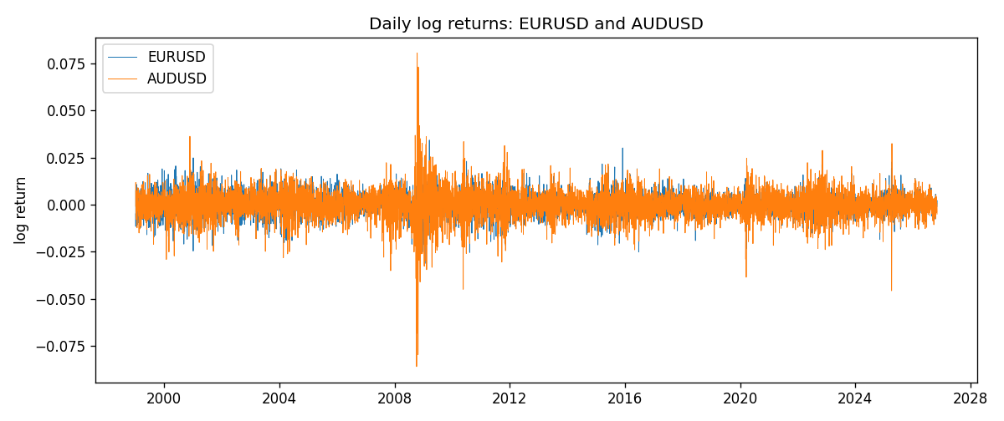
ADCC rho path with nested DCC and Pearson r
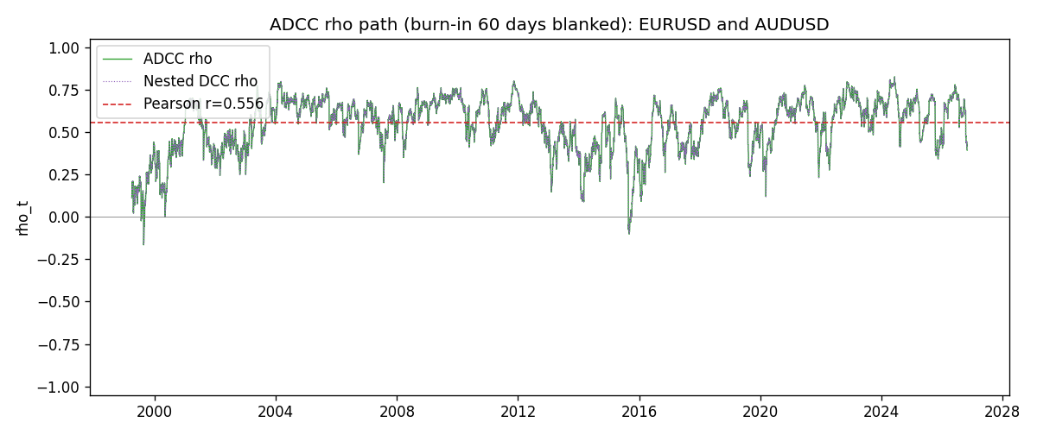

Data report
Every matched row that entered the ADCC recursion is stored in the sibling Excel workbook named EURUSD-AUDUSD_ADCC_D1.xlsx. Embedding all rows as a Word table is impractical at this length; the Word file holds the column list, column summaries, and the first and last 15 matched rows.
Columns: time, EURUSD_open, AUDUSD_open, EURUSD_high, AUDUSD_high, EURUSD_low, AUDUSD_low, EURUSD_close, AUDUSD_close, EURUSD_tick_volume, AUDUSD_tick_volume, EURUSD_spread, AUDUSD_spread, EURUSD_real_volume, AUDUSD_real_volume, EURUSD_log_return, AUDUSD_log_return, EURUSD_sigma, AUDUSD_sigma, EURUSD_z, AUDUSD_z, EURUSD_n, AUDUSD_n, q11, q22, q12, rho_adcc, rho_dcc
Column summaries (matched calculation rows)
column | count | mean | std | min | 25% | 50% | 75% | max
EURUSD_open | 7201 | 1.1813268 | 0.15086382 | 0.8272 | 1.08608 | 1.16615 | 1.29393 | 1.5995
AUDUSD_open | 7201 | 0.75197127 | 0.13525779 | 0.4785 | 0.66105 | 0.73142 | 0.80912 | 1.10284
EURUSD_high | 7201 | 1.1864593 | 0.1514619 | 0.8326 | 1.0902 | 1.17128 | 1.29926 | 1.6038
AUDUSD_high | 7201 | 0.75602178 | 0.13581838 | 0.4878 | 0.6647 | 0.7349 | 0.81518 | 1.10795
EURUSD_low | 7201 | 1.1763142 | 0.15018707 | 0.8227 | 1.08202 | 1.16257 | 1.28834 | 1.5865
AUDUSD_low | 7201 | 0.74791431 | 0.13457219 | 0.4775 | 0.6577 | 0.72758 | 0.8042 | 1.0975
EURUSD_close | 7201 | 1.1813656 | 0.15083992 | 0.8267 | 1.08601 | 1.16617 | 1.29395 | 1.5997
AUDUSD_close | 7201 | 0.75202148 | 0.13524071 | 0.4786 | 0.6612 | 0.73175 | 0.80916 | 1.10169
EURUSD_tick_volume | 7201 | 103004.8 | 173409.64 | 469 | 9389 | 52708 | 99441 | 1471626
AUDUSD_tick_volume | 7201 | 77347.024 | 138135.9 | 109 | 5434 | 43320 | 71320 | 1234623
EURUSD_spread | 7201 | 19.396195 | 16.574381 | 0 | 8 | 12 | 30 | 50
AUDUSD_spread | 7201 | 30.819886 | 16.887485 | 0 | 13 | 30 | 50 | 50
EURUSD_real_volume | 7201 | 4.0238636e+10 | 1.6675367e+11 | 0 | 0 | 0 | 0 | 3.6149665e+12
AUDUSD_real_volume | 7201 | 5.2420906e+09 | 1.2538049e+11 | 0 | 0 | 0 | 0 | 3.811512e+12
EURUSD_log_return | 7201 | -7.54e-06 | 0.00580172 | -0.03123819 | -0.00324684 | 0 | 0.00325501 | 0.03433183
AUDUSD_log_return | 7201 | 2.459e-05 | 0.00754509 | -0.08602525 | -0.00385511 | 0.00028229 | 0.00415126 | 0.0806166
EURUSD_sigma | 7201 | 0.00556816 | 0.00169761 | 0.00258094 | 0.0043251 | 0.00539042 | 0.00649631 | 0.01459042
AUDUSD_sigma | 7201 | 0.00694037 | 0.0027925 | 0.0039097 | 0.00551336 | 0.00627022 | 0.00758621 | 0.03854477
EURUSD_z | 7201 | -0.00321466 | 1.0000304 | -5.7791779 | -0.62048956 | -0.00162978 | 0.60927264 | 5.2059249
AUDUSD_z | 7201 | -0.00447606 | 1.0001122 | -8.4753791 | -0.60257456 | 0.04050471 | 0.63765387 | 5.0114091
EURUSD_n | 7201 | -0.38703675 | 0.59314482 | -5.7791779 | -0.62048956 | -0.00162978 | 0 | 0
AUDUSD_n | 7201 | -0.38804513 | 0.62437318 | -8.4753791 | -0.60257456 | 0 | 0 | 0
q11 | 7201 | 1.0005436 | 0.19392157 | 0.57035211 | 0.86852662 | 0.97994394 | 1.1013786 | 2.2659934
q22 | 7201 | 1.0009488 | 0.21930381 | 0.60496946 | 0.8672409 | 0.96463757 | 1.0831319 | 3.1012299
q12 | 7201 | 0.53950943 | 0.19500781 | -0.19001706 | 0.41364608 | 0.55107676 | 0.66195328 | 1.405618
rho_adcc | 7201 | 0.53994954 | 0.16058101 | -0.16563563 | 0.43557937 | 0.58268498 | 0.6649104 | 0.8257941
rho_dcc | 7201 | 0.53994954 | 0.160581 | -0.16563557 | 0.43557937 | 0.58268492 | 0.6649104 | 0.82579407
First 15 matched rows (selected columns)
time | EURUSD_log_return | AUDUSD_log_return | EURUSD_z | AUDUSD_z | EURUSD_n | AUDUSD_n | q11 | q22 | q12 | rho_adcc | rho_dcc
1999-01-05 | -0.0048360507 | -0.00080418179 | -0.73670334 | -0.13357517 | -0.73670334 | -0.13357517 | 1 | 1 | 0.53858345 | 0.53858345 | 0.53858345
1999-01-06 | -0.011547966 | 0.011836351 | -1.7726243 | 1.9321031 | -1.7726243 | 0 | 0.98573028 | 0.96935033 | 0.52484705 | 0.53692463 | 0.53692463
1999-01-07 | 0.0076280636 | 0.0088650256 | 1.1253257 | 1.3498088 | 0 | 0 | 1.0531444 | 1.055849 | 0.4017036 | 0.38094376 | 0.38094381
1999-01-08 | -0.010902799 | 0.00031515916 | -1.6046966 | 0.042277698 | -1.6046966 | 0 | 1.0593571 | 1.079294 | 0.43770516 | 0.40934603 | 0.40934607
1999-01-11 | -0.007103287 | 0.0072213815 | -1.0173547 | 1.1030518 | -1.0173547 | 0 | 1.1061642 | 1.0450111 | 0.42276564 | 0.39321442 | 0.39321447
1999-01-12 | 0.0045103728 | -0.0048608485 | 0.6436057 | -0.74576652 | 0 | -0.74576652 | 1.103063 | 1.0499962 | 0.37551367 | 0.3489247 | 0.34892476
1999-01-13 | 0.010845346 | -0.0078902098 | 1.5672065 | -1.2205385 | 0 | -1.2205385 | 1.080712 | 1.0341708 | 0.35016951 | 0.33122812 | 0.33122819
1999-01-14 | 0 | -0.002696916 | -0.0013677153 | -0.41471501 | -0.0013677153 | -0.41471501 | 1.1229645 | 1.0481033 | 0.28111213 | 0.25911617 | 0.25911626
1999-01-15 | -0.010153245 | 0.007123101 | -1.4605229 | 1.1005462 | -1.4605229 | 0 | 1.0869008 | 1.0203638 | 0.27449319 | 0.26065082 | 0.2606509
1999-01-18 | 0.0036256946 | 0.00094592471 | 0.50939106 | 0.14084855 | 0 | 0 | 1.1188289 | 1.0261502 | 0.21795759 | 0.2034158 | 0.20341589
1999-01-19 | -0.00017235436 | 0.0072225153 | -0.026015969 | 1.1367878 | -0.026015969 | 0 | 1.0910259 | 0.99452987 | 0.21605465 | 0.20741357 | 0.20741366
1999-01-20 | -0.0031939256 | 0.0012507819 | -0.46666619 | 0.19090529 | -0.46666619 | 0 | 1.0562449 | 1.0038672 | 0.21106499 | 0.20497258 | 0.20497267
1999-01-21 | 0.0030215416 | 0.00078094498 | 0.44536264 | 0.12020183 | 0 | 0 | 1.0296127 | 0.97364526 | 0.2044152 | 0.20416245 | 0.20416254
1999-01-22 | -0.0012075213 | -0.012252745 | -0.18277331 | -2.0220242 | -0.18277331 | -2.0220242 | 1.0034262 | 0.94393075 | 0.20247883 | 0.20804958 | 0.20804966
1999-01-25 | -0.0030251979 | -0.0039591468 | -0.46418436 | -0.6084016 | -0.46418436 | -0.6084016 | 0.97312687 | 1.0425293 | 0.2104814 | 0.20897044 | 0.20897052
Last 15 matched rows (selected columns)
time | EURUSD_log_return | AUDUSD_log_return | EURUSD_z | AUDUSD_z | EURUSD_n | AUDUSD_n | q11 | q22 | q12 | rho_adcc | rho_dcc
2026-10-13 | 0.0037402957 | 0.0035007712 | 1.0798817 | 0.76774162 | 0 | 0 | 0.94459977 | 0.76402264 | 0.52351942 | 0.61624834 | 0.61624834
2026-10-14 | -0.0037582255 | -0.0015193215 | -1.0839435 | -0.34441773 | -1.0839435 | -0.34441773 | 0.95197297 | 0.76053169 | 0.53317953 | 0.62661748 | 0.62661748
2026-10-15 | 0.0056053107 | -0.0075447063 | 1.5996087 | -1.7077501 | 0 | -1.7077501 | 0.9593292 | 0.74248654 | 0.52823601 | 0.62589269 | 0.62589268
2026-10-16 | 0.0017724895 | 0.0033906408 | 0.48867479 | 0.71603379 | 0 | 0 | 1.0095788 | 0.81246325 | 0.42658979 | 0.47101907 | 0.47101911
2026-10-19 | -0.0025394633 | 0.0050859986 | -0.71471333 | 1.0837541 | -0.71471333 | 0 | 0.98544612 | 0.80466456 | 0.42512586 | 0.47741235 | 0.47741239
2026-10-20 | 0.0023881672 | 0.0034620426 | 0.67095337 | 0.72700875 | 0 | 0 | 0.9707553 | 0.81782695 | 0.38862869 | 0.43616344 | 0.4361635
2026-10-21 | -0.00032046717 | 0.0036066384 | -0.093812121 | 0.76184333 | -0.093812121 | 0 | 0.95475254 | 0.81031061 | 0.39296709 | 0.44677103 | 0.44677108
2026-10-22 | -0.0015949606 | -0.0012672558 | -0.46302482 | -0.27810988 | -0.46302482 | -0.27810988 | 0.92560809 | 0.80470965 | 0.37968162 | 0.43993285 | 0.4399329
2026-10-23 | -0.001338521 | 0.0023765656 | -0.39348754 | 0.51045162 | -0.39348754 | 0 | 0.90403067 | 0.78363123 | 0.37316979 | 0.44336258 | 0.44336262
2026-10-26 | -0.0022706559 | -0.0032032829 | -0.67384211 | -0.71303302 | -0.67384211 | -0.71303302 | 0.88144697 | 0.76910295 | 0.35662867 | 0.43313763 | 0.43313768
2026-10-27 | -0.004152342 | 0.0016669876 | -1.2381142 | 0.36205033 | -1.2381142 | 0 | 0.8690933 | 0.76288326 | 0.36200279 | 0.44457975 | 0.44457979
2026-10-28 | 0.0022262927 | 0.0040915541 | 0.65081963 | 0.91264099 | 0 | 0 | 0.89089515 | 0.74513395 | 0.33818221 | 0.41506899 | 0.41506904
2026-10-29 | 0.0022571351 | -0.0040915541 | 0.6647153 | -0.92346708 | 0 | -0.92346708 | 0.87721655 | 0.7499875 | 0.34782671 | 0.42882739 | 0.42882743
2026-10-30 | -0.0011458446 | 0.0010102376 | -0.34413588 | 0.21801741 | -0.34413588 | 0 | 0.86464875 | 0.75526965 | 0.31939885 | 0.39524145 | 0.3952415
2026-11-02 | 0.002120569 | -0.0049184984 | 0.63679074 | -1.1227692 | 0 | -1.1227692 | 0.8424847 | 0.73521383 | 0.30890846 | 0.39250208 | 0.39250214

